Robot-Controlled Motorcycle

Razvan Bonta
30421

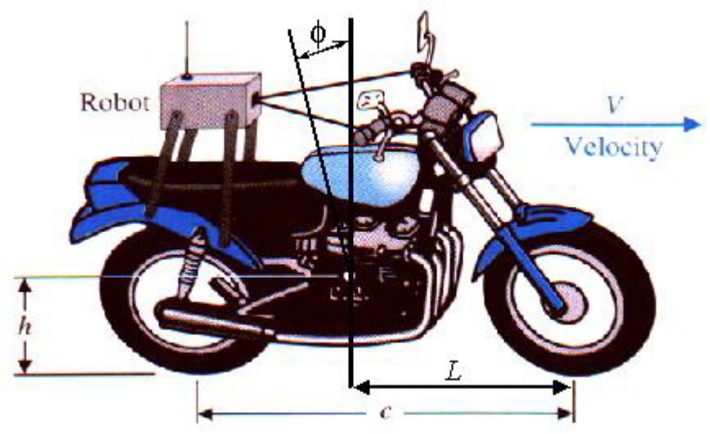
Consider a robot-controlled motorcycle shown in Figure 1. The motorcycle will move in a straight line at constant forward speed V. Let ϕ denote the angle between the plane of symmetry of the motorcycle and the vertical. The desired angle ϕ_{d} is equal to zero: ϕ_{d}(s) = 0.

Figure 1. Robomoto

The control goal is to maintain the motorcycle in the vertical position and maintain the prescribed position in the presence of disturbances.
The variable to be controlled is the motorcycle position from the vertical (ϕ).
The control design specification is: the closed-loop must be stable.
The motorcycle model is given by:
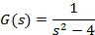
The controller is given by:
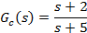

Control is accomplished by turning the handlebar. The front wheel rotation about the vertical is not evident in the transfer function. Also, the transfer functions assume a constant forward speed V, which means that we must have another control system at work regulating the forward speed (it is not considered in this problem).

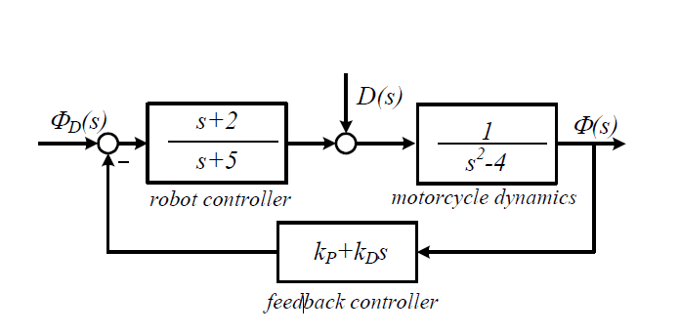
Assembling the components of the feedback system gives us the following system configuration:
The parameters we want to adjust are in the feedback loop .

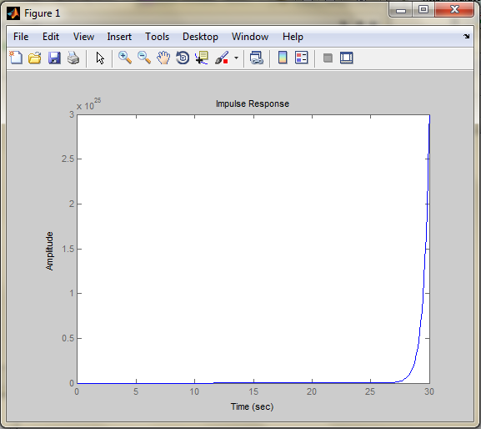
1. Is the motorcycle stable? Plot the impulse response of the open-loop system (motorcycle alone, without any control) and explain.
The impulse response in this case is:
This means that the system is unstable, as can be seen from the motorcycle model function. The system poles are 2 and -2, and because one of them is positive, the system is therefore unstable.
The MATLAB plot for this shows the same thing.

2. Select key tuning parameters, the feedback gains kP and kD. Follow the steps below:
- Determine the closed-loop transfer function from ϕ d(s) to ϕ(s) when the disturbance D(s) = 0.
The open-loop transfer function of the above system is:

From this we compute the closed-loop transfer function as:

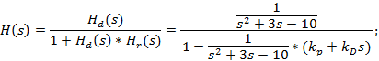
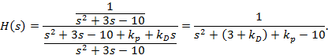

- Use the Routh-Hurwitz criterion to analyze the closed-loop system stability. Determine the range of values for kP and kD for which the closed-loop system is stable.( kP >0 and kD>0);

Applying the Routh-Hurwitz criterion we obtain:
We compute a as 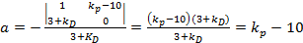
In order for the system to be stable both 3+ and must be positive. From this we deduce that and . Since both constants must be positive, the final result will be .

- Choose a pair of values for and and determine the closed-loop poles.

In order to keep the system stable, I chose and .
The closed-loop function is now .
The closed-loop poles are the roots of , which are -3 and -1.

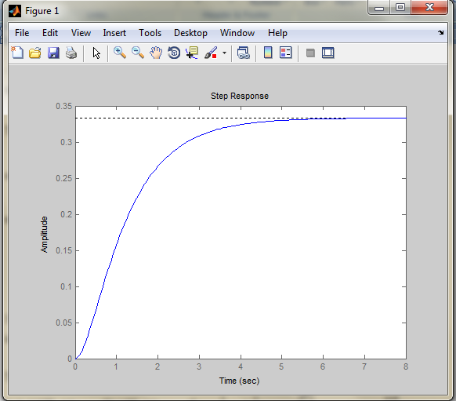
- Plot the step response (ϕ d(t)=1, D(t) =0), analyze the plot and the real-life situation when the input is a unit step. Discuss the steady-state error.

The system response is
From the plot we can clearly see the system response is overdamped. This could have been seen from , where and .
Such a situation is when the angle input changes and then keeps the same value, so, for example, the motorcycle crosses a tilted road.
The steady state error, computed as
)
means that there will be a small difference between the input and the output at stabilizing time.

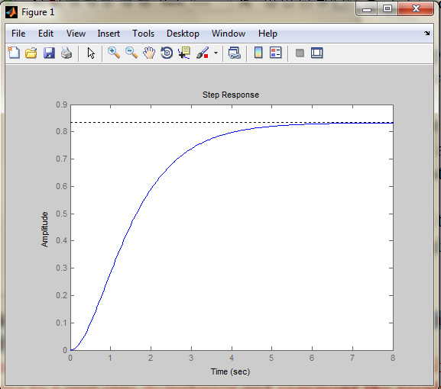
3. Plot the system response to a step disturbance. Consider ϕ_{d}(s)=0 and the D(s) as a unit step input. Analyze the result.

The system response in this case is:
ϕ=ϕ_{D}(s)*H₀₁(s)|_{D(s)=0}+D(s)*H₀₂(s)|_{Φd(s)=0}=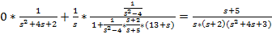
ϕ=
The system is stable even in this case, though the amplitude of the result is much greater, which means that the motorcycle will be a bit tilted, but not enough to fall. It also takes about 5 seconds to stabilize.

4. Change the values of the parameters kP and kD, within the admissible range, plot the system response to a unit step disturbance and comment the results.

For this, I chose the following sets of values for and : 14 and 5, 12 and 8 and 11 and 10.
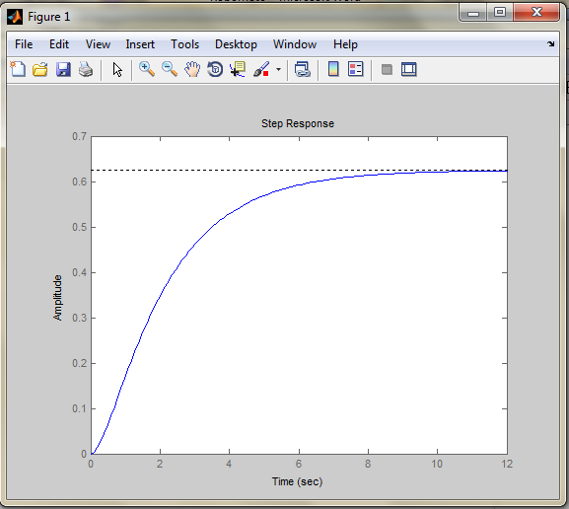
In the first case the transfer function is: .
For the second one the transfer function is:
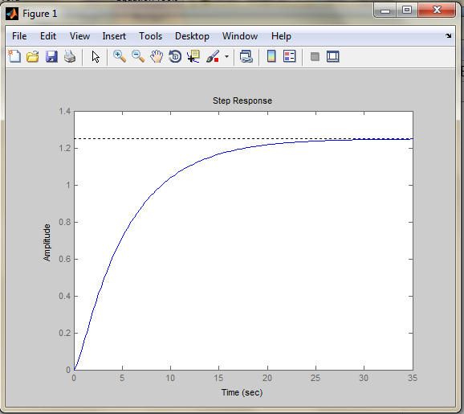
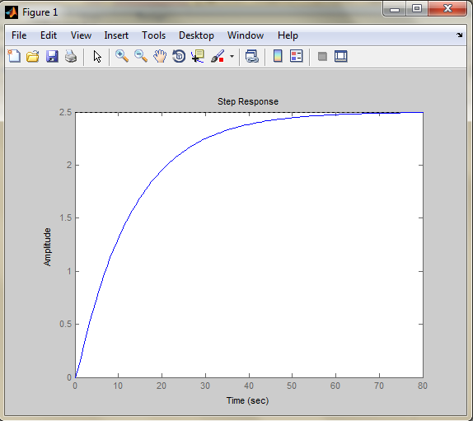
And last, for the third case, the transfer function is: :
All these systems are still stable. Even from the first one, we can notice a longer stabilizing time (about 7 seconds, whereas in the initial choice of constants there were 4 seconds), but a smaller amplitude (0.62 vs. 0.82). The stabilizing time is much greater in the second case (about 23 sec), with a greater amplitude of 0.5. For the last one we notice an even greater stabilizing time (50 sec) and an even greater amplitude (2.5). From these, I can assume that the amplitude decreases as increases and the stabilizing time increases asincreases.

Conclusion
The robot-controlled motorcycle system is stable for certain values of the constants on the negative feedback. Moreover, it is overdamped, as it has real poles. More interesting is what happens when we consider a disturbance (a step one in our case). The system remained stable for the choices of constants above, but changed their amplitudes and stabilizing times.

